COMP 4522 Database 2: Assignment 2 Part 3

Austin Bec & Shawn Tian

1. In general, SQL and Prolog are both very similar in the way that queries are written and handled. Granted, they are both declarative languages that are logic driven. The queries are essentially the same. However, each language has a different way of representing what they’re trying to do. Take the third query, for example,

“SELECT e.*

FROM employee e

WHERE e.EMPLOYEE_NAME NOT IN (

SELECT SUBORDINATE

FROM supervise);”

We want to find the top employee, and the best way to do that is to look for the employee who does not have their name as a subordinate because that would indicate they are at the top of the chain. We can then write the same query in Prolog, but it will look different.

“employee(Employee), \+(_, Employee). “

This is essentially the same as the SQL query, only written in Prolog. The \+ operator is used in Prolog to check for negation, rather than the standard way in SQL of using NOT IN. This shows that queries written in both languages are very similar despite having different commands to do the same thing.

SQL is best used for querying and managing relational databases, compared to Prolog, which is better for logical reasoning. Similarly, they both have their theories based on relational algebra. However, Prolog has a greater emphasis on logic. Another similarity between SQL and Prolog is that the queries are declarative, meaning they specify the desired solutions rather than how to find the solution.

1. Generally, both parts and their queries were written with the same logic in mind. Both languages have similar ways of querying the information in their tables for SQL and Facts and rules for Prolog. Looking at both queries side by side, you can tell they follow a very similar structure despite using different keywords and notation. This can be seen in the previous example for question 1 in query 3, where the queries are written in different languages but follow the same structure and logic.
2. The main difference is in the languages themselves. SQL is more keyword-based, and Prolog is symbolic. Another key difference is that Prolog uses facts and rules to make statements about the entities. This differs from SQL, where the data is represented in tables, with the rows representing the entity. The row could be similar to a fact because it declares something about an entity.
3. The data in Prolog is represented as Facts, which tells you about the data’s relationships and properties. Predicates can also be used to express facts. Prologue rules define the relationship and infer new information based on the facts and other rules. Predicates can also be used as rules to represent relationships or conditions in queries.

## Python output

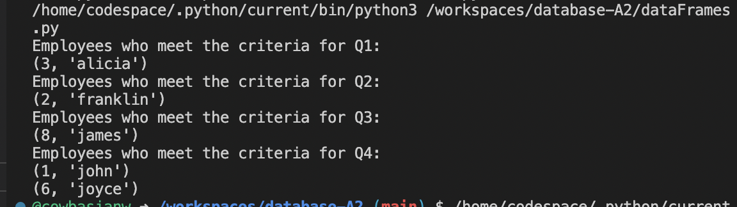

## Prolog output

